Stakeholder Register for E-Pharma

Prepared by: Swaroopa Tirumalareddy Date: June 3, 2020

Name | Position | Internal/External | Project Role | Contact Information
Shiva Rama Krishna Vodnala   | Team Lead and Developer | Internal | Team Member | S538103@nwmissouri.edu
Krishna Sumanth Koyyalamudi  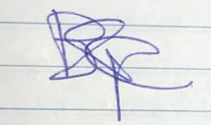 | Developer and Content Writer | Internal | Team Member | S538345@nwmissouri.edu
Swaroopa Tirumalareddy  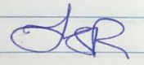 | Manager and  Content Writer | Internal | Project  Manager | S538426@nwmissouri.edu
Gopichand Bandarupalli  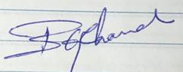 | Developer | Internal | Team Member | S538305@nwmissouri.edu

